**BOLT IOT Capstone Project**

**Temperature Anomaly Detection and Alert System**

Name: Harshal Abhyankar

1. Build the circuit for temperature monitoring system, using the Bolt and LM35 sensor.

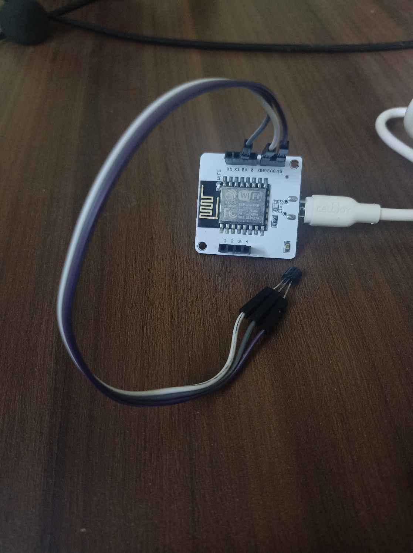

1. Create a product on the Bolt Cloud, to monitor the data from the LM35, and link it to your Bolt.

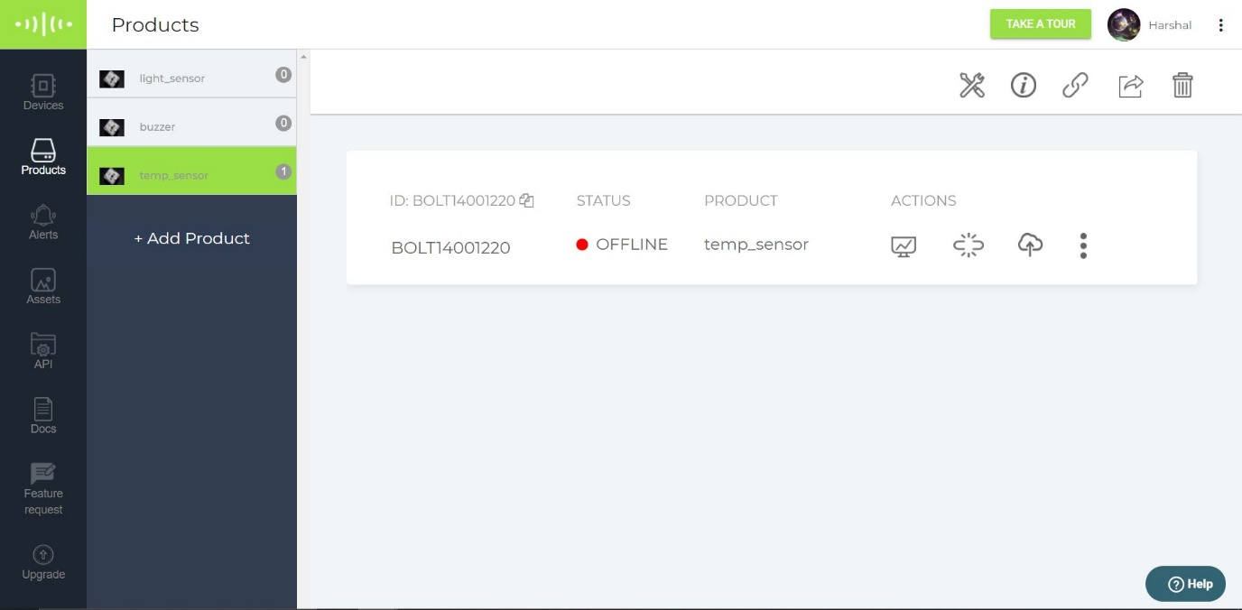

1. Write the product code, required to run the polynomial regression algorithm on the data sent by the Bolt.

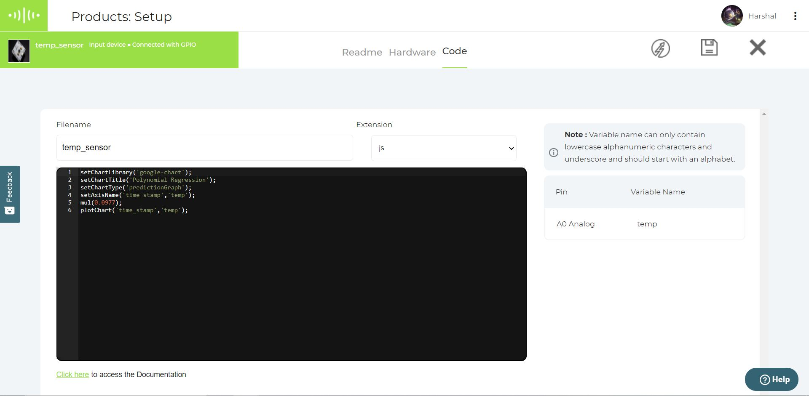

1. Keep the temperature monitoring circuit inside your fridge with the door of the fridge closed, and let the system record the temperature readings for about 2 hours.

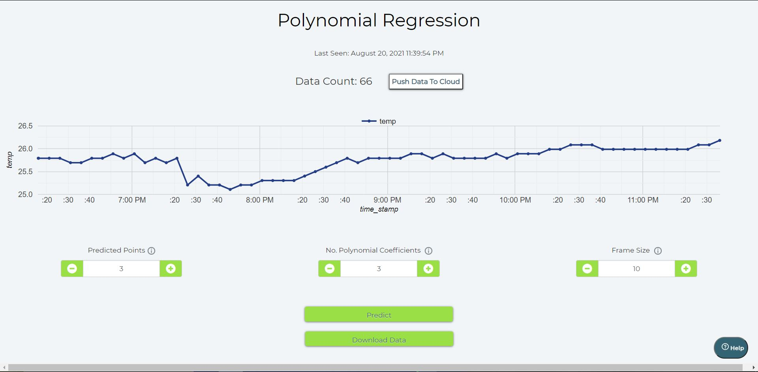

**e)** Using the reading that you received in the 2 hours, set boundaries for the temperature within the fridge.

The boundaries set are 25 degrees and 26.3 degrees Celsius. (I recorded room temperature since I didn’t have a battery to run the module without direct connection and simulated rise in temperature using heater.)

**f)** Write a python code that will fetch the temperature data, every 10 seconds, and send out an email alert, if the temperature goes beyond the temperature thresholds you decided on in objective ‘e’.

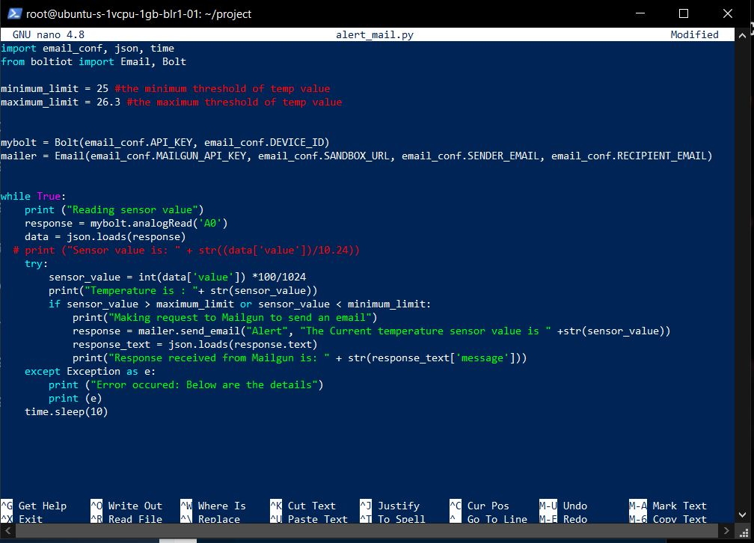

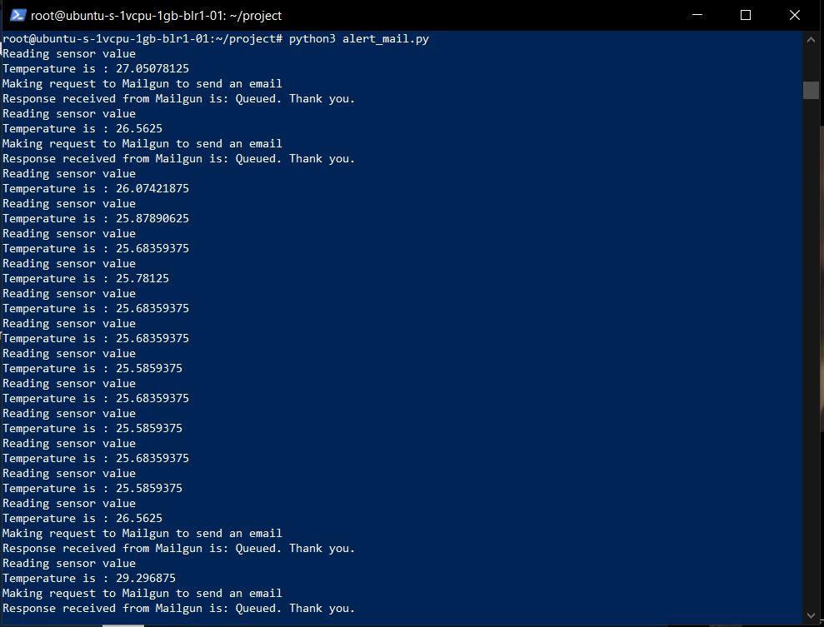

**g)** Modify the python code, to also do a Z-score analysis and print the line “Someone has opened the fridge door” when an anomaly is detected.

Part 1 of code:

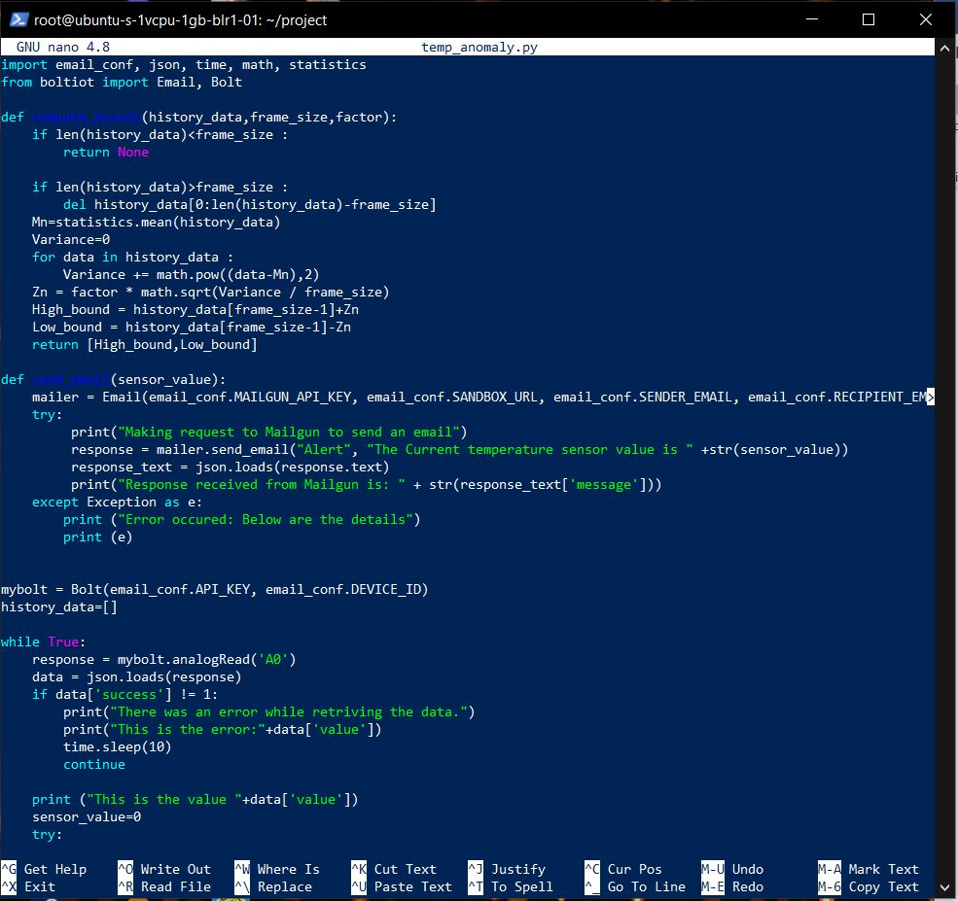

Part 2 of code:

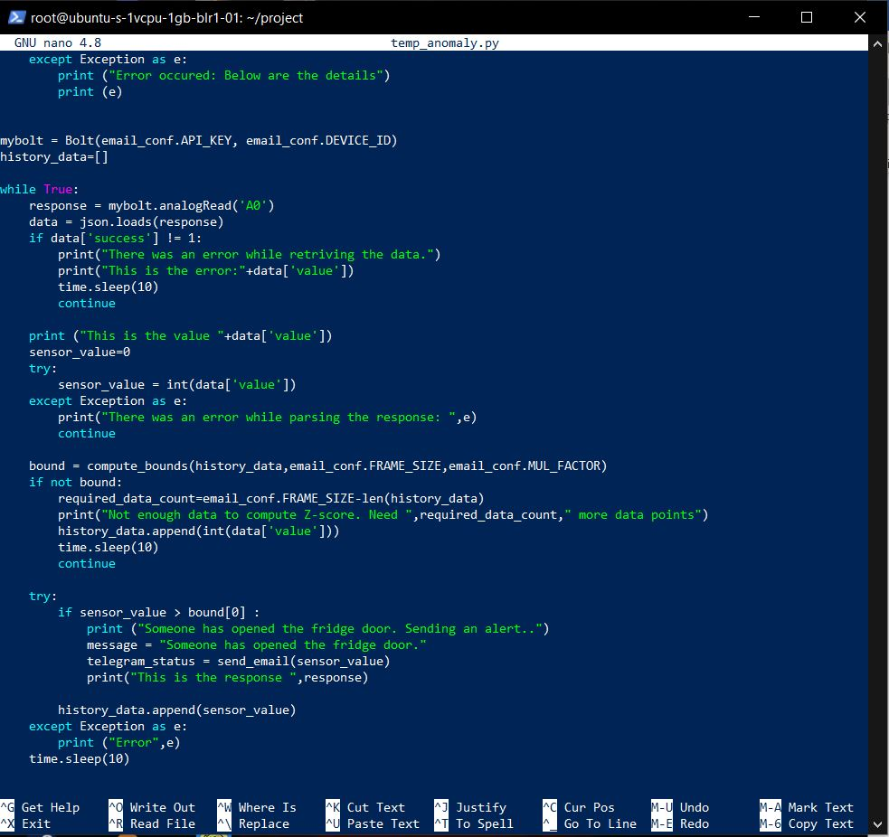

**h)** Tune the Z-score analysis code, such that, it detects an anomaly when someone opens the door of the fridge.

I tuned the Z-score analysis code by reducing the MUL_FACTOR value to 1 to make it more sensitive to temperature change.

**Results:**

